The University of the West Indies - Cave Hill Campus

Faculty of Science and Technology

Centre for Resource Management and Environmental Studies (C.E.R.M.E.S)

ASSET_MGT

A$$3t_mgt

This layer allows for the inspection of transformers with TM01.

Shore-to-ship Power for Cruise Ships on ‘100% Renewables’ in the Bridgetown Port, Barbados

Submitted by Dario J Hoyte (Student ID: 407001289)

Submitted to Prof. Olav Hohmeyer

RNEM6010 – Energy Economics

Date: May 7, 2016

Table of Contents

List of Figures ii

List of Tables ii

Abstract/Summary 3

Current Problem & Aim 3

Shore-to-ship plugin Technology 5

Current Activity at the Bridgetown Harbour 7

The Harbour Expansion Plan 9

Defining the Basic Power Demand 10

Load curve for Type-1 Ships 10

Load curve for Type-2 Ships 11

Annual Load Curve with business as usual scenario 11

Annual Load Curve with forecasted ‘Sugar Point’ development 12

Results with Hohmeyer’s simulation 12

Discussion 13

Conclusion 14

Limitations 15

Recommendations 15

References 16

# List of Figures

Figure 1: Showing the energy matrix of Barbados as of 2008 (Source: Castalia, 2010) 4

Figure 2: Simple demonstration of Shore-to-ship technology infrastructure (Source: ABB, 2010) 6

Figure 3: An aerial shot of the Bridgetown Port in 2015 (Source: BPI, 2015) 7

Figure 4: Percentage distribution of cruise ship guests arrivals to Barbados in the 2014-2015 season (Archive source: Foster & Ince Cruise Services Inc. data archives - Retrieved April 2016) 7

Figure 5: Graph depicting projected increase of cruise ship passenger arrivals to the target year of 2050, under the business as usual setting. 8

Figure 6: Planned layout of Sugar Point development (Online image source: BPI, 2013 – Retrieved on Apr 15, 2016 at http://www.sugarpointbarbados.com/masterplan/ilustrative-plan/) 9

Figure 7: Graph depicting projected increase of cruise ship guest arrivals to the target year of 2050, under full expansion in 2020. 10

Figure 8: Graph of the average load curve for Type-1 cruise ship for one day 10

Figure 9: Graph of the average load curve for Type-2 cruise ship for one day 11

Figure 10: Assumed annual load curve for power requirements by 2050 distributed over a given year, with the ‘business as usual’ scenario 11

Figure 111: Assumed annual load curve for power requirements by 2050 distributed over a given year, with ‘Sugar Point development’ scenario 12

# List of Tables

Table 1: Table showing the variation of cruise passenger arrivals from 2010-2011 season to the 2014-2015 season 8

Table 2: Showing the results from Dr. Hohmeyer's simulation after plugging in the various scenarios 12

# Abstract/Summary

Whilst exploring the work of Dr. Olav Hohmeyer (2015), it is evident that his theoretical synergy of renewable technologies to meet 100% of the current load power demands in the island of Barbados proves to be instrumental in this report. This paper has attempted to take this research a step further, by adding new loads of an innovative technology, called Shore-to-ship plugins, to the island’s main harbour. An introspective look was taken for the growing cruise industry and the planned expansions for Bridgetown Harbour, then tailored applications of this Shore-to-ship technology were simulated herein in efforts to reduce the overall levelized cost of electricity (LCOE). Since these simulations ran on the basis of 100% renewable energy sources, it was important to size the grid generators and storage capacity carefully to match the varying demand loads. In order to complete this task, this paper took into consideration the projected load profiles for berthed cruise ships in the target year of 2050, whilst deliberating two particular scenarios - a business as usual scenario; a scenario where the port saw expansion in the form of the Sugar Point development. The LCOE in the business as usual scenario was determined to be 0.242 BBD/kWh, whereas, for the Sugar Point expansion change it was determined to be 0.237 BBD/kWh. These costs were comparatively lower than the cost for electricity generation using the island’s conventional system as expressed in Hohmeyer’s 2015 research to be about 0.566 BBD/kWh in 2013. These intriguing results have very grave implications on the use fossil fuels versus renewables.

# Current Problem & Aim

All over the world, developing countries are continuously searching for ways in which to balance energy use and its economic weighting factor. Energy is essential for the livelihood of a country and is one of the main driving features needed for progress and comfortable operation in the globe’s constantly changing social, economic and environmental setting. Fundamentally, many social and economic activities would not be allowed to even occur without energy and it is important that countries find a balance as practical energy comes at a cost. However, in order to facilitate this energy demand, we have been subjecting the environment to existing and constantly emerging problems, strains and damages. This is mostly due to the fact that the majority of energy production across the world is still very much based on conventional fossil fuel energy generation. Regrettably, this means mass releases and emissions of carbon dioxide (C02) and other greenhouse gases (GHG) into the earth’s atmosphere. These gases aid in global warming and instigate other hazardous events, and as such, this perilous covenant for energy is actually threatening the very life of the planet. Thankfully in recent times we see the mobilization of many focus groups, organizations and governments around the world who are trying to focus their efforts on utilizing cleaner energy alternatives. The goal is to continue the normal operation and regular running of the numerous developmental and functioning processes without impairing energy stability with the use of said cleaner alternatives. This delicate task tries to ensure that such societal processes do not suffer, as they are some of the main features behind economic solidity and are therefore vital for the sustainability and longevity of each and every country. Nevertheless, if humans of the world continue to gamble their energy demand over the environment, there may soon be no more places to sustain or develop.

For the 166 mi2 developing island state of Barbados, the energy balancing game is a reality of everyday life. With the approaching 300,000 citizens on the small nation, the Barbados Light & Power (BL&P) - the main supplier of electrical energy - is required to meet yearly consumption power demands of close to 1TWh (EC, 2014). The BL&P generate their electricity from the use of roughly 240MW installed capacity of conventional fossil fuel generators, supplying around two-thirds of the island’s yearly consumption demand to the commercial and business sectors (EC, 2014). The share size of this consumption split to these commercial sectors supports the many claims of a developing and advancing state. As shown in Figure 1, the energy supply required here is almost 100% derived from unfavourable fossil fuels imports.

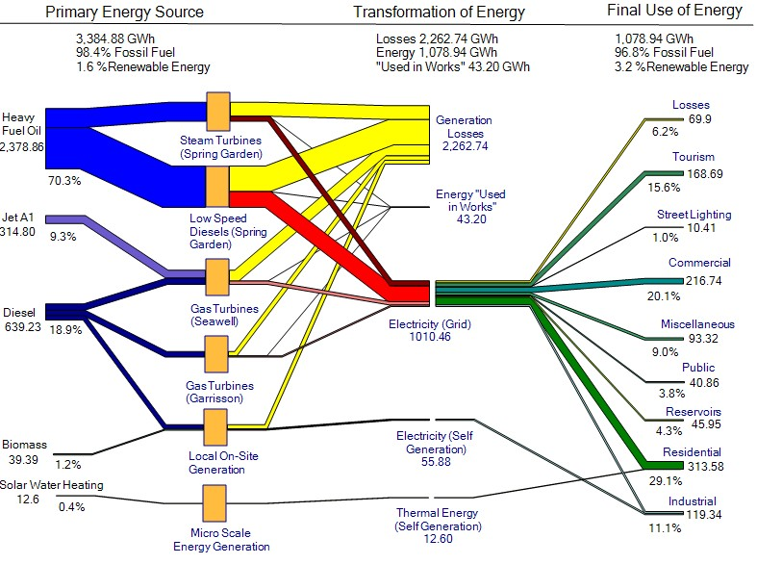

Figure 1: Showing the energy matrix of Barbados as of 2008 (Source: Castalia, 2010)

Although this data is dated to 2008, a similar energy matrix is expected for current times as there has been only in recent years an incorporation of renewables in the form of photovoltaics (PV) and wind integration. Shamefully, the penetration percentage of electricity generation from renewable sources across the island is still very small. The main economic issue here is that fossil fuel prices fluctuate erratically, leaving uncertainty in the cost of electricity ($/kWh) in this primarily conventional system. This constant fluctuation infers insecurity and instability in the island’s economy, as the economic activities therein are clearly significantly tied to an energy supply which is heavily dependent on conventional fuels.

One of the main capital income situations in Barbados is largely derived from the country’s rewarding tourism industry. For such a small nation, the tourism sector contributed about BBD$3,370.2 million of income which was estimated to be 36.1% of the 2014 GDP, and this economic input is seemingly set to increase within the next decade (WTTC, 2015). This boost and massive chunk of the Barbadian economy is mainly due to the hundreds of thousands of tourist arrivals yearly to the island’s shores. Special mention is given to the cruise tourism subsection of the industry, where a study duly noted that about 58% of said passenger arrivals during the winter periods are drawn from this subdivision (ARA Consulting, 2001). This percentage has surely risen since this study has been done as statistics show that the thriving cruise sector industry has grown, increasing the amount of landed passengers yearly by about 7.5% since 1985 to 2009 (Worrell et al., 2009). However, even with all the warm smiles and sunny beaches, there is unfortunate trouble in paradise.

With this influx of cruise ships to the island’s shores there is an ever emerging situation of docking power demand. When these ships are berthed, they are currently required to operate their diesel engines to sustain hoteling abilities and power requirements. With this, a lot of harmful GHG emissions are released into the atmosphere. Imagining 5 to 6 cruise ships berthed at a time per day, one can begin to get a first visualization and feel for the share size of contribution of said emissions. Let’s propose we utilize the island’s main grid in order to facilitate docking power to the ships via direct plugin to the ships. This would be done in efforts to counteract the issue of said harmful emissions. This seems like a fantastic idea, but unfortunately this Shore-to-ship plugin, using the conventional grid system, would not eliminate GHG emissions but simply transfer the origin of these pollutants. Let’s not forget that Barbados is already contributing to the significant amount of GHG emissions plaguing the earth, as its grid supply is still generated from almost 100% fossil fuels. Shore-to-ship plugin from conventional power would notably increase the island’s GHG emissions, increase fossil fuel import expenditure and put extra strain on the economy, environment and the physical grid. The hoteling power of the tourism industry already adds an approximate load of about 16% of that supplied by the grid (Castalia, 2010). Adding this additional hoteling load demand of cruise ships will unquestionably increase this percentage.

So now the real challenge is trying to determine whether or not we can use 100% clean electricity from the grid to implement the Shore-to-ship notion to supply the berthing power demands of ships. This essentially means the entire grid’s generation resources would need to be adjusted to renewable energy sources. Using Dr. Olav Hohmeyer’s (2015) research and model for implementing 100% renewable energy in Barbados, it is intended in this case study to attach the predicted load and variate the source inputs to gain a favourable outcome. Whilst settling on an optimistic target year for 100% renewables in Barbados to be the year 2050, the main aims and objectives here for this paper are as follows:

* To determine the current and projected future estimated power demand for cruise ships berthed at the port.
* To determine the feasibility of Shore-to-ship plugin using as close to or fully 100% renewable power sources.
* Give a first glance at the likely levelized cost of electricity (BDS$/kWh) in said system to give comparison to a conventional fossil fuel application.

# Shore-to-ship plugin Technology

Shore-to-ship plugin technology, also known as cold-ironing, has been a topic of interest since the ramping up of the cruise industry in the last few decades. This technology is emergent mainly due to discussions surrounding the reduction of global air pollution. Simply defined, this systematic approach supplies ships that are docked with electricity from the onshore grid in order to meet their berthing power demands. The main advantage here is that ships which are berthed do not have to self-power using their fossil fuel engines, thus reducing their overall CO2 and GHG emissions. This is surely supported with studies done by the IMO (2005), which looked at providing estimates for emission reductions with use of such technologies. Additionally, another prospective advantage is the market penetration of energy related income, as the countries with these technologies in port can essentially impose on ships to buy electrical energy from the onshore grid while docked. On the other hand, ship companies are generally not obligated to come to any country and may pull out from berthing at particular ports due to these newly forced docking regulations. This would mean a potential loss of tourism and other income revenue to the country, as well as international services such as freighting. One of the main ways to counteract this would be to globally regulate the technology, as acceptance to this somewhat new advancement is still relatively low (ABB, 2010). Another main disadvantage is based on the fact that the additional load on the conventional grid supply simply does not fully solve the problem of polluting emissions. These potentially harmful emissions are now transferred to the respective country’s generating conventional plants.

Nevertheless, there are many other concerns and challenges which this technology faces before it can even be implemented. As suggested in an AAPA (2005) paper, legal barriers can stagnate the employment of this technology, especially in places where the regulatory framework and policies are not in place to support it. It is important to note that without this legal framework, the host country is at risk in events of any unfortunate occurrence and there would be an absence of clear and concise guidelines to follow for all stakeholders and actors involved. Furthermore, engineering challenges would exist such like the need for additional shore infrastructure, cabling systems and technical components to meet ship standard electrical requirements. The main issue here is that the systems must be tailored in a way to allow a variety of electrical voltages and frequencies, as electrical requirements for the various ships are not standardized across the board. Grid infrastructure in Barbados may also need to be revamped and adjusted accordingly in order to take the additional loads. Likewise, the ships which are not equipped to accept this technology would have to undergo modifications for such. Figure 2 gives a basic demonstration of the various infrastructure and components involved with Shore-to-ship plugin technology.

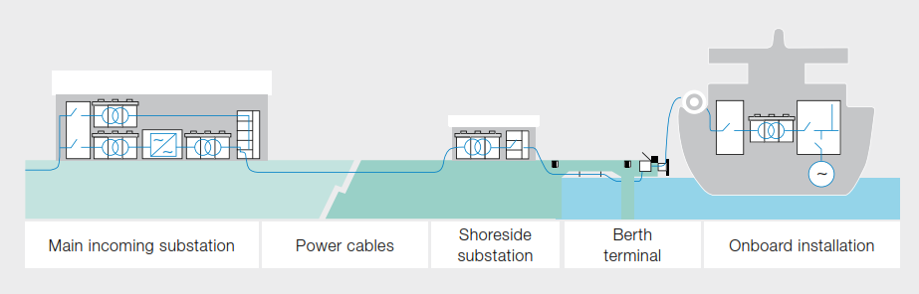

Figure 2: Simple demonstration of Shore-to-ship technology infrastructure (Source: ABB, 2010)

It goes without saying that the task to employ all of these vital factors would be daunted by the high initial capital investment cost. Undertaking such a huge project will surely be an expense in the millions of US dollars as realized in the 2001 implementation of the Princess Cruise Lines Shore-to-ship power station in Juneau, Alaska (AAPA, 2005). Moreover, after implementation, there will be most definitely the operational and maintenance cost aspect to take into consideration. All of these upfront and operational costs can put severe economic burden on a country’s economy. To add from a societal perspective, implementing this technology in places where it is not familiar, will more or less likely require outside input and further education of members in the population.

Although there exist many boundaries to be overcome, Shore-to-ship solutions seem to be viable in the efforts of GHG emission reductions. Many feasibility studies have been done all over the world in many countries to include this technology in the respective seaports. One of the world's first Shore-to-ship power project was completed by a company called ABB for the port of Gothenburg, Sweden, in the year 2000 (ABB, 2010). Since then there have been over twenty successful implementations of this technology in countries such as the USA and the UK (AAPA, 2005).

The Shore-to-ship system sizing requirements are dependent on the estimated maximum load demand at the ports berths at any given time. The next few sections will attempt to determine what would be the required demand in the target year 2050. Hopefully, the data represented will be helpful in trying to size the Shore-to-ship plugin system properly, as it will be necessary to install equipment that will adequately meet the cumulative requirements for the projected increased load in years to come. The system would be sized from scratch, as the Bridgetown Port currently does not carry this technology as yet.

# Current Activity at the Bridgetown Harbour

The Bridgetown Port, Barbados is an artificial coastal breakwater harbour which was opened on May 6, 1961 (BPI, 2011). Since its grand opening, the port has seen increased development since the 1970’s until now, where seven large berths are now realized (BPI, 2016). Such expansion was mostly in efforts to facilitate the docking of bigger tankers and cruise ships, bringing much more needed business to the island. For the Barbados, this deep water harbour provides many jobs and services, opens access portals to the outside world and is revered as one of the most organized and efficient harbours in the region. An aerial shot of the current state of the port can be seen in Figure 3.

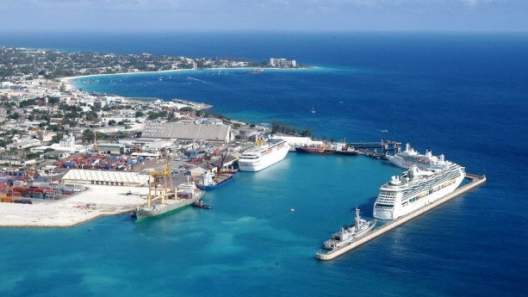

Figure 3: An aerial shot of the Bridgetown Port in 2015 (Source: BPI, 2015)

For the port, a financial year for shipping activity begins in August of one year and ends in July of the following calendar year. During the winter periods of November to April, the Bridgetown Port exceedingly becomes a major hub of activity, providing an inflow of jobs and foreign exchange revenue. This is mainly due to an influx of cruise ship arrivals during this period, boasting approximately 750,000 guests yearly (BPI, 2011). Figure 4 represents a percentage distribution of these cruise ship passenger arrivals to the island for the 2014-2015 season. This data was collected from Foster & Ince Cruise Services (FICS) who are the port agents for about 98% of the vessels entering the Bridgetown Harbour and, henceforth, they are considered a reputable source.

Figure 4: Percentage distribution of cruise ship guests arrivals to Barbados in the 2014-2015 season (Archive source: Foster & Ince Cruise Services Inc. data archives - Retrieved April 2016)

The Bridgetown harbor attracts cruise ships that have the capacity to carry over 4,000 guests per ship. These cruise ships usually berth in the port for between 10-48 hours before leaving. Although there have been relatively steady increases of about 7.5% annually for cruise visitor arrivals since 1985 until 2009, this percentage increase has almost leveled to an average 1.0% annually since then. Table 1 below shows this variation over the course of five seasons commencing from 2010.

Table 1: Table showing the variation of cruise passenger arrivals from 2010-2011 season to the 2014-2015 season

|  |  |  |  |
| --- | --- | --- | --- |
| **Season** | **Passenger Arrivals** | **Increase from previous season** | **Data Source** |
| 2010-2011 | 745,175 | **\*** | BPI (2011); FICS Statistical Data (2016) |
| 2011-2012 | 751,627 | 0.9% | FICS Statistical Data (2016) |
| 2012-2013 | 761,153 | 1.3% | FICS Statistical Data (2016) |
| 2013-2014 | 767,755 | 0.9% | FICS Statistical Data (2016) |
| 2014-2015 | 775,432 | 1.0% | FICS Statistical Data (2016) |

**\***N.B: The increase from the season previous to 2010-2011 is not indicated as 2010 is the starting point of the considered range.

One can consider a few possible and suspected justifications behind this nominal variation increase of on average 1.0% per year.

One scenario is that the holding capacity of the current port configuration and arrangement has been reached. However, although there are 4-6 ships per day regularly during the high season, this does not occur every single day. There is usually around two days per week during this high season period where the port only sees from 0-3 ships per day. disThis means there is still unutilized space and times for even more arrivals in the port. Another reason for this decreased rate in comparison to what it used to be, could be a plateaued interest from the varying cruise companies. However, it is suspected that even with the supposed plateaued interest, the fact that the cruise lines are growing their ships to include even more holding capacity would help to justify this 1.0% increase yearly. This justification can be realised from the example in 2010, which saw a fewer cruise calls than 2009 but still resulted in more landed passenger arrivals (BPI, 2011).

With this data, it is desired to seek a projected trend from 2015 to the year 2050. In an attempt to assist in minimizing under compensation, let us assume an increased future growing trend of an additional 0.5% as compared to the average represented for the seasons in Table 1. Henceforth, this paper will assume for now on that passenger growth rate is positively stuck at an average deviation increase of 1.5% annually from the 2015-2016 season and onwards. In Figure 5, this likely progression over time is graphed.

Figure 5: Graph depicting projected increase of cruise ship passenger arrivals to the target year of 2050, under the business as usual setting.

With this, we get a growth in passenger arrivals by 2050 to approximately 1.304 million people which is factor of about 1.7 of the documented cruise arrivals for the 2014 season. It is believed that this is a good indication of a possible worst case scenario regarding the increased influx of passenger arrivals between 2015 until 2050 under business as usual.

# The Harbour Expansion Plan

As previously expressed, there have been expansions to a variety of port facilities during the last few decades and in recent years there are plans for even more major future and new developments. These new developments fall under the project codenamed and deemed as “Sugar Point”, which is set to be completed by the year 2020 (BPI, 2013). A layout of the development plan can be seen in Figure 6, where the proposed expansion will most importantly include three new massive berthing extensions.

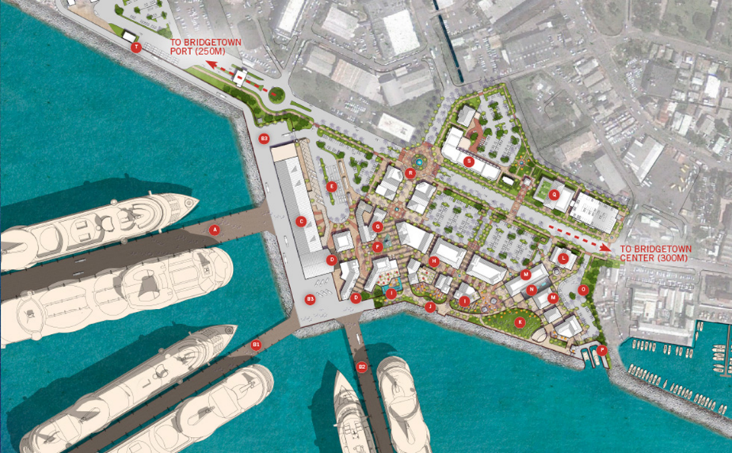

Figure 6: Planned layout of Sugar Point development (Online image source: BPI, 2013 – Retrieved on Apr 15, 2016 at http://www.sugarpointbarbados.com/masterplan/ilustrative-plan/)

This expansion is all in efforts to incorporate and provide docking of larger cruise ships and greater cruise passenger arrival capacities. By completion, this would mean the addition of six new berths and would see the release of the flour mill berth for commercial-tourism use. This flour mill berth has been an area of contention as it is rather undeveloped and is located north of the port’s current main centre of operations. The developments seek to tie in this particular berth with the rest of the operation or to use it mainly as a backup berth.

Nevertheless, with all good hopes this would indicate in total an additional seven new active berths to the already seven that exist for a total of 14 berths.

In essence, the current retaining capacity of the Bridgetown Port will be practically doubled on any given day after expansion is complete. This would potentially also mean an approximate doubling of the total amount of passengers incoming by 2020, and by extension, a doubling of potential current cruise ship berthing load requirement for a given busy day. This proposed trend is demonstrated in Figure 7, where the 2020 season sees a doubling in incoming passengers whilst keeping a plateaued annual increase of 1.5%.

As can be appreciated, the business as usual trend model up until 2020 is assumed and then the port is opened to its full capacity by its completion in this same year. By the year 2050, a potential increase of passengers to 2.609 million is realised. Further models would be necessary in order to decipher particular scenarios where the port opens in phases as it is constructed. Nonetheless, with this scenario as portrayed in Figure 7, a growth rate of factor of approximately 3.4 of the 2014-2015 cruise arrivals count is realised.

Figure 7: Graph depicting projected increase of cruise ship guest arrivals to the target year of 2050, under full expansion in 2020.

# Defining the Basic Power Demand

The following assumption will be utilized to complete the task of determining load features and curves. The loads represented here are based on an average size passenger cruise ship. With the collected data, it is assumed that an average passenger ship carrying 2,200 guests produces approximate berthed necessity loads of about 10MW and peaks at 15MW. This assumption has been formulated by a combination of data gathered from ABB (2010) and FICS 2016 statistical archives. Also, this paper refers to two types of ships, Type-1 and Type-2, which will be used to identify ships which berth for 10 hours then leave and those which berth for 24 hours then leave respectively.

### Load curve for Type-1 Ships

The average Type-1 cruise ship docks usually docks in port around just after six o’clock in the morning, and leaves port just before five o’clock on the very same day. These ships are usually berthed for around 10 hours. In Figure 8, based on the patterns in movement and activity of the masses, an attempt is made to recreate a load curve profile for the 10 hours of load demand at berth.



Figure 8: Graph of the average load curve for Type-1 cruise ship for one day

When the ship is docked and fully secured at around 6:30am, it is anticipated that this is when the shore plugin will be connected to the ship. At this time, onboard activity is recorded to be in full swing and reaching the maximum load of 15MW. This activity then dwindles around 8:30am, when almost all guests disembark the ship to go on their various shore excursions. It is alleged that during this down time, the ship is functioning just to retain the operation of basic necessities, as many guests are not onboard to utilize the various amenities. Around 1:30pm sees the gradual return of guests from their excursions and as consequence, a ramping up of load back to maximum about an hour or so before departure. This is simply because the all-aboard call is at this time and all passengers are mostly back on the ship utilizing the various facilities.

### Load curve for Type-2 Ships

In contrast, we see in Figure 9 the potential load curve pattern over a 24 hour period. Although not precise, it gives a good understanding of the hoteling power demand required by the ships throughout a 24 hour cycle.

Figure 9: Graph of the average load curve for Type-2 cruise ship for one day

At midnight, all services are running and nightlife is booming on the ship and, henceforth, maximum load of 15MW is assumed. This load drops when people go to sleep for a few hours, switching off various amenities. It picks back up when the kitchen starts up for breakfast and when other activities like gym and exercise classes commence. The pattern then follows on to the Type-1 load curve pattern, as the same basic activity cycles take place for that 10 hour allotment of time. The rest of the evening, it is assumed that the guests are back on board completely using all the various cinemas, casinos, restaurants, bars and other facilities that will keep the power demand at the maximum 15 MW.

### Annual Load Curve with business as usual scenario

With the combination of the Type-1 ships and the Type-2 ships load curve, the frequency of these varying class of cruise ships were matched to that of the 2014-2015 season data from FICS sources. This enabled a load profile for the berthed cruise ships for that season, an average year. Using the factor of 1.7 as determined before under the 2050 business as usual scenario, a load curve for the projected power requirements expected for that year is represented in Figure 10.



Figure 10: Assumed annual load curve for power requirements by 2050 distributed over a given year, with the ‘business as usual’ scenario

Please be reminded that this year represented starts from August and ends the following calendar year at the end of July. With this, a total load demand of about 112,822MWh (~113GWh) is realised and expected for an entire year by 2050, with peaks at approximately 153MW.

### Annual Load Curve with forecasted ‘Sugar Point’ development

Following on, a factor 3.4 load profile in relation to the 2014-2015 data was favourably ascertained and represented in Figure 11. This projected load profile for the year 2050, explains the power requirements essential by that year after undergoing the forecasted Sugar Point development which is set for completion in 2020.



Figure 111: Assumed annual load curve for power requirements by 2050 distributed over a given year, with ‘Sugar Point development’ scenario

With this, a total load demand of about 225,644MWh (~226 GWh) is realised and expected for an entire year by 2050, with peaks at approximately 306MW. Be reminded again that the year represented starts at the beginning of August and ends the following calendar year at the end of July

# Results with Hohmeyer’s simulation

After adding the various scenarios to Dr. Hohmeyer’s simulation and manipulating the different variables, the following encouraging set of reasonably optimized results have been achieved. With the use of wind, PV, pump storage and biodiesel, it was managed to lower the levelized cost of electricity (LCOE) to favourable points.

Table 2: Showing the results from Dr. Hohmeyer's simulation after plugging in the various scenarios

Interestingly, a lower LCOE has been achieved for both business as usual and Sugar Point expansion scenarios in comparison to the no additional load situation. Also, with all of the simulations, it was noted that the wind power variable is higher than that of the PV. This has some possibly interesting implications on the geographical characteristics of Barbados, although technically speaking wind energy is still currently a cheaper form of electricity generation than PV. The lowest LCOE was realized in the Sugar Point expansion, however this is at the expense of almost double the biodiesel dependency than the other two scenarios.

|  |  |  |  |
| --- | --- | --- | --- |
| **Detail** | **No additional load to current grid situation** | **Port plugin Load (Business as usual)** | **Port plugin Load (Sugar Point expansion)** |
| Additional Load (GWh) | - | 112.82 | 225.64 |
| Wind Power (MW) | 350 | 350 | 400 |
| PV (MW) | 150 | 200 | 100 |
| Volume Storage (MWh) | 2,000 | 2,000 | 3,000 |
| Biodiesel (t) | 11,476 | 11,990 | 23,800 |
| Over-production (MWh) | 624,162 | 606,530 | 517,372 |
| LCOE (BBD/kWh) | 0.244 | 0.242 | 0.237 |

# Discussion

It is remarkable how in the optimized solutions during the simulation, lower LCOE were realized for each additional increased final load of the plugin requirement. A lot more research would need to be done in order to fully understand this phenomenon. However in every solution, using wind energy in copious amounts seems to really have an impact on the final cost of electricity. Also, from a first glance, it is interesting to note that the cruise ship high season demand does fall in the season for higher wind speeds on the island. Higher wind speeds generally mean a higher potential for generation of more electricity.

Continuing on, some may wonder whether or not the renewable power from the Shore-to-ship plugin will be available all the time when needed, and how this would vary in the various yearly seasons. Although the resources of wind and sun are intermittent, for the location of Barbados (13N, 59W) there seems to be ample amounts and fairly uninterrupted flows of these resources. With proper regulation and storage, a suitable synergy can be achieved where there should be absolutely no variation in the supply of power. These mechanisms of regulation and sufficient storage would help to eradicate any unsureness in stability and assist in addressing issues of intermittency.

With a 100% renewable energy power supply in this remote location of Barbados, much needed foreign reserves will be retained. Currently, the government of Barbados is spending quite a substantial amount of its foreign reserve income on imported fossil fuels. It was estimated that the fuel share in the island’s cost of electricity is almost 75% of this total cost (Hohmeyer, 2015). This staggering realization brings to light a festering problem of an oil dependent system that needs to be addressed in order to reinforce the economy. With 100% renewables on the grid, rest assured that a lot more foreign reserves would be retained, the cost of electricity should substantially drop for the general consumer and there should be no fluctuating or unexpected cost increases. These varying features would have very positive effects on the island’s economy and could potentially boost local investments and citizens’ expenditure. The main and probably most obvious restrictive factor prohibiting a quick start up of such a venture would be that of the initial cost and setup of all the infrastructure.

Nevertheless, besides saving money and economic stability, the whole point of using the selected renewables of wind and solar is the fact that they emit zero GHG and CO2 pollutants during their operating lifetimes. However when biodiesel is burnt, there is still a release of emissions into the atmosphere, but in a less harmful way than direct fossil fuel applications. This is why it was necessary in this study to still minimize the dependency use of biodiesel in the simulations. If this strong ethical battle for reduced emissions did not exist, there are some arrangements that could have been utilized which provide a lesser LCOE whilst using biodiesel in higher amounts.

Using the simulated models for shore plugins, it is seen that the cruise lines can also potentially save on the cost for their power demand during berthing. This is obviously reliant on the agreements and diesel prices which have been contracted by the cruise lines and their partners, and whether or not this is at a fixed price. Renewables in this case can offer a stability in the berthed electricity cost as opposed to the ever fluctuating pricing unsureness of fossil fuels. It is fine to say that the gas prices of latter 2015 and early 2016 have trended downwards but, this won’t be forever. Historic trends have shown that when this price drop occurs, there usually follows a gradual or almost instant rise in the same cost subsequently. Henceforth, buying electricity from the Shore-to-ship plugin on a 100% renewable grid setting may actually offer some cruise lines a better economic advantage and price stability.

One thing also that is certainly up for discussion is whether or not the models created in this paper can be adapted or changed to accommodate further future fluctuating demands such as the additional berthing demands for other types of vessels. The answer is simply yes, most certainly. The beauty about this Shore-to-ship technology is that all the components necessary to build the systems are tried, proven and well explored forms of equipment. These components are already existing and working in real life situations, as realistically most of them comprise of things which are actually on the present grids themselves. Henceforth, making additions or amendments should not prove to be a difficult task.

Although not shown in the results, an additional load of 251.5GWh/a was added to the Sugar Point scenario which already had the lowest LCOE as mentioned before. This figure came from work done on the electric vehicle (EV) load necessity in Barbados, if all private vehicles on the road were to be traded in for an EV. After a variety of simulations, an even lower LCOE was realised to be 0.227 BBD/kWh as opposed to 0.237 BBD/kWh without the EV load. This lends itself to discussions, as it seems that the larger the load demand is through the simulation, the better the ability of the simulation to give an even lower LCOE. Yet again, this solution was realised with more amounts of wind capacity, 450MW, in comparison to the 150MW installed capacity of PV. A storage capacity of 2000MWh also played an important role. Also, the biodiesel demand was fairly reasonably down to 32,023t. Arguably, this solution is reasonably optimized and wind once more shows itself to be a favourable technology for use in this Barbados context. However, there would be a lot more issues without the solar inputs to handle the heavy loading peaks during the day. Henceforth, it is important that these technologies are operated seamlessly with each other.

# Conclusion

Present-day net generation of Barbados grid is 918.1GWh, with peaks at 157.4MW (LPH, 2013). By adding the varying loads of the scenarios presented in this paper, it is evident that there would an increase in yearly generation requirements. For business as usual with the Ship-to-shore plugin installed, the grid will be required to generate about 1,031.1GWh with peaks at 310.4MW, by 2050. Whereas with the planned Sugar Point expansion, including the Ship-to-shore plugin will increase grid load demand to net generation requirements of about 1,144.1GWh with peaks at 463.4MW, by 2050.

This research helped to give somewhat of a good feasibility assessment of using Shore-to-ship technology in Barbados on 100% renewable grid, noting carefully the various challenges and positive outcomes of implementing this technology at the Bridgetown Port. Due to the intermittent nature of wind and solar, storage will play an important role in the execution and implementation as such. Nevertheless, based on the advantageous timing of the high cruise ship season which syncs with high wind periods, all of the optimized solutions seem to fit well with higher installed capacities of wind in comparison to solar.

The LCOE in the business as usual scenario and the Sugar Point expansion scenario was determined to be 0.242 BBD/kWh and 0.237 BBD/kWh respectively. Furthermore, with some tinkering in the simulation, the LCOE with no additional load of the port plugin was optimized to be about 0.244/kWh in comparison to Hohmeyer’s simulated research (2015) of 0.250 BBD/kWh. Conversely, the cost of electricity under the island’s current traditional system is averaged to be 0.566 BBD/kWh in 2013 (Hohmeyer, 2015). These astounding results carry some very serious implications for the eradicated use of fossil fuels. This is because inferences can be made here to support a higher possibility of less costly electricity bills on a 100% renewable grid - even with the additional load of Shore-to-ship plugin technology. Additionally, it seems that the bigger the added load is, the simulation lends its way towards a lower LCOE after being optimized. With much more investigation and further drive of this idea into practicality, this can actually be the beginning to the end for fossil fuels in the island’s electrical generation process. These highly significant findings surely gives room and will hopefully continue to gain interest, instigating further and more detailed research.

### Limitations

* The time to extensively do more research on the particular area is not enough as it is still a relatively new technology application and a lot more digging would need to be done.
* It has not been taken into consideration on the load curve models that cruise ships are being built to operate more energy efficiently.
* Limited availability to cruise line information and secured diesel prices.
* The availability of the funding to construct and maintain the shore-to-ship plugin technology.
* High upfront cost to generate power using renewable energy.
* Shortage of experts versed in the shore-to-ship technology.
* Use of scarce funds to import specialists to operate the shore-to-ship technology.
* There may be reluctance/objection to the use of the shore-to-ship technology.
* The tendency of ships to find alternate cities to dock in so as to avoid paying the levy for using the country’s grid.
* Difficulty in producing the hoteling levels of energy usually produced by the ship.
* Inconsistency and unsureness of power generation using renewable energy – there is no guarantee as there can be acts of God (e.g Hurricanes).

### Recommendations

* The world on a whole should look at globally regulate Shore-to-ship technology.
* Enact local policies in Barbados to govern the various forms of technology which have been used in the model: Shore-to-ship plugin and renewable technologies.
* Ensure that a significant portion of government funding is allocated to implementing the shore-to-ship technology and 100% renewable energy Barbados, since the benefits exceeds the costs.
* Train a cadre of persons who will be responsible for the operation of the shore-to-ship technology.
* Train specialists to manage the various renewable energy technologies on the grid as grid stability is key in this application.
* Find a use for overproduction or seek additional means of storage.
* Launch an education campaign to inform persons about the many benefits of this technology.
* Continue to market one’s country as a beautiful, hassle-free and relaxing destination.
* Conduct an environmental impact assessment (EIA) and EIA follow-up before and after respectively.

# References

AAPA. (2005). *Use of shore-side power for ocean going vessels - White Paper Report.* Retrieved from World Ports Climate Initiative: http://wpci.iaphworldports.org/data/docs/onshore-power-supply/library/1264151248_2007aapauseofshore-sidepowerforocean-goingvessels.pdf (Downloaded on April 21, 2016)

ABB. (2010). *Shore-to-ship power.* Retrieved from ABB: https://library.e.abb.com/public/8f916bbe49d92d1ac12579680032f273/Shore-to-ship-power-2010-low.pdf (Downloaded on April 15, 2016)

ARA Consulting. (2001). *Juneau Tourism Management Planning Process: Barbados Cruise Tourism Strategy Case Study.* Retrieved from Juneau: http://www.juneau.org/tourism2/cbjtourism/barbados.pdf (Downloaded on April 17, 2016)

BPI. (2011). *Barbados Port Handbook 2011-13.* Colchester, UK: Land & Marine Publications Ltd. Retrieved from Barbados Port Inc: http://www.barbadosport.com/sites/default/files/Barbados_2011_book.pdf (Downloaded on April 15, 2016)

BPI. (2013). *About: Sugar Point*. Retrieved from Sugar Point, Barbados: http://www.sugarpointbarbados.com/about-sugar-point/

BPI. (2016). *About Us: Port Overview*. Retrieved from The Barbados Port Inc.: http://www.barbadosport.com/about-us

Castalia. (2010). *Sustainable Energy Framework for Barbados.* USA: Castalia Limited/Inter-American Development Bank .

EC. (2014). *Annual Report 2014 - Powering a sustainable energy future.* Retrieved from Emera Caribbean (Inc.): http://www.emeracaribbean.com/site-emera/media/EmeraCaribbean/2015%20Emera%20Caribbean%20Inc.pdf (Downloaded on April 20, 2016)

Hohmeyer, O. (2015). *A 100% renewable Barbados and lower energy bills.* Flensburg, Germany: ZNES.

IMO. (2005). *Prevention of air pollution from ships.* Retrieved from US Environmental Protection Agency: https://www3.epa.gov/otaq/regs/nonroad/marine/ci/marpol-propose-revision-4-05.pdf (Downloaded on April 20, 2016)

LPH. (2013). *Annual Report 2013.* Bridgetown, Barbados: Light & Power Holdings Ltd.

Worrell, D., Belgrave, A., Grosvenor, T., & Lescotta, A. (2009). *An Analysis of the Tourism Sector in Barbados.* Bridgetown, Barbados: The Central Bank of Barbados.

WTTC. (2015). *Travel & Tourism - Economic Impact 2015 Barbados.* Retrieved from World Travel & Tourism Council: https://www.wttc.org/-/media/files/reports/economic%20impact%20research/countries%202015/barbados2015.pdf (Downloaded on April 17, 2016)